Modifying an html page using Chrome Dev tools is easy.

1. First, open Chrome and navigate to the desired web page. In this example we use: https://content.bellevue.edu/cst/WEB/WEB230/week-9/exercise-9.3.html
2. Press F12 to open the html script.
3. Make sure Elements is selected at the top left of the script window. Click the Styles tab if it is not already selected.
4. Hover through the code until you have found the element on the web page you wish to change. The web page will highlight the elements as you hover of their code. For this exercise, locate the <div class=”columns-container”> and click the dropdown arrow to the left of it.
5. You’ll need to modify the left and right column. First, click the <div class=”left-column”> tag. A series of windows will appear in the styles-tabbed window. Locate this one: 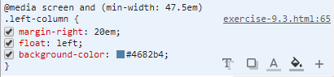
6. Hover your mouse of the three bottom right dots to bring up the styles options. The paint-bucket icon to the left of the plus sign will bring up the function to “Add background color”. Click this and then enter: #4682b4 in the hexcolor window:
7. 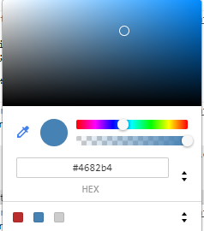
8. Do the same with the right column, located in the div tag right below the left-column tag. Once completed, the end result should look like this.

